--DATA WRANGLING AND CLEANING—

*CHECKED FOR DUPLICATES = 0

SELECT * FROM survey

--ANALYZE EACH COLUMN--

SELECT DISTINCT FROM survey

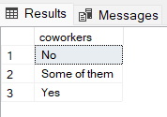

--FILTERING OUT NULLS --

SELECT * FROM survey

WHERE Timestamp IS NOT NULL

AND Age IS NOT NULL

AND Gender IS NOT NULL

AND Country IS NOT NULL

AND self_employed IS NOT NULL

AND family_history IS NOT NULL

AND treatment IS NOT NULL

AND work_interfere IS NOT NULL

AND no_employees IS NOT NULL

AND remote_work IS NOT NULL

AND tech_company IS NOT NULL

AND benefits IS NOT NULL

AND care_options IS NOT NULL

AND wellness_program IS NOT NULL

AND seek_help IS NOT NULL

AND anonymity IS NOT NULL

AND leave IS NOT NULL

AND mental_health_consequence IS NOT NULL

AND phys_health_consequence IS NOT NULL

AND coworkers IS NOT NULL

AND supervisor IS NOT NULL

AND mental_health_interview IS NOT NULL

AND phys_health_interview IS NOT NULL

AND mental_vs_physical IS NOT NULL

AND obs_consequence IS NOT NULL

--CREATING #TEMPTABLE—

SELECT * INTO #NoNull_Survey FROM survey

WHERE Timestamp IS NOT NULL

AND Age IS NOT NULL

AND Gender IS NOT NULL

AND Country IS NOT NULL

AND self_employed IS NOT NULL

AND family_history IS NOT NULL

AND treatment IS NOT NULL

AND work_interfere IS NOT NULL

AND no_employees IS NOT NULL

AND remote_work IS NOT NULL

AND tech_company IS NOT NULL

AND benefits IS NOT NULL

AND care_options IS NOT NULL

AND wellness_program IS NOT NULL

AND seek_help IS NOT NULL

AND anonymity IS NOT NULL

AND leave IS NOT NULL

AND mental_health_consequence IS NOT NULL

AND phys_health_consequence IS NOT NULL

AND coworkers IS NOT NULL

AND supervisor IS NOT NULL

AND mental_health_interview IS NOT NULL

AND phys_health_interview IS NOT NULL

AND mental_vs_physical IS NOT NULL

AND obs_consequence IS NOT NULL

--CREATING NEW TABLE FROM #TEMPTABLE—

SELECT * INTO TechSurvey FROM #NoNull_Survey

--DELETING INVALID AGES--

SELECT DISTINCT TOP 5 AGE

FROM TechSurvey

ORDER BY Age DESC

SELECT DISTINCT TOP 5 AGE

FROM TechSurvey

ORDER BY Age ASC

DELETE FROM TechSurvey

WHERE AGE > 72 AND AGE < 18

--FILTERING NON-TECH COMPANY ANSWERS--

FROM TechSurvey

GROUP BY tech_company

HAVING tech_company = 'No'

SELECT * FROM

TechSurvey

WHERE tech_company = 'YES'

--UPDATING VALUES TO CREATE UNIFORMITY—

UPDATE TechSurvey

SET [no_employees] = '5-26'

WHERE [no_employees] = '25-JUN'

UPDATE TechSurvey

SET [comments] = 'N/A'

WHERE [comments] IS NULL

UPDATE TechSurvey

SET [state] = 'N/A'

WHERE [state] IS NULL

UPDATE TechSurvey

SET [no_employees] = 'Male'

WHERE [no_employees] = 'M'

UPDATE TechSurvey

SET [no_employees] = 'Female'

WHERE [no_employees] = 'Female (cis)'

UPDATE TechSurvey

SET [no_employees] = 'Other'

WHERE [no_employees] = 'non-binary'

--CHANGING COLUMN NAMES FOR BETTER COMPRHENSION AND UNIFORMITY--

EXEC sp_rename 'TechSurvey.state'

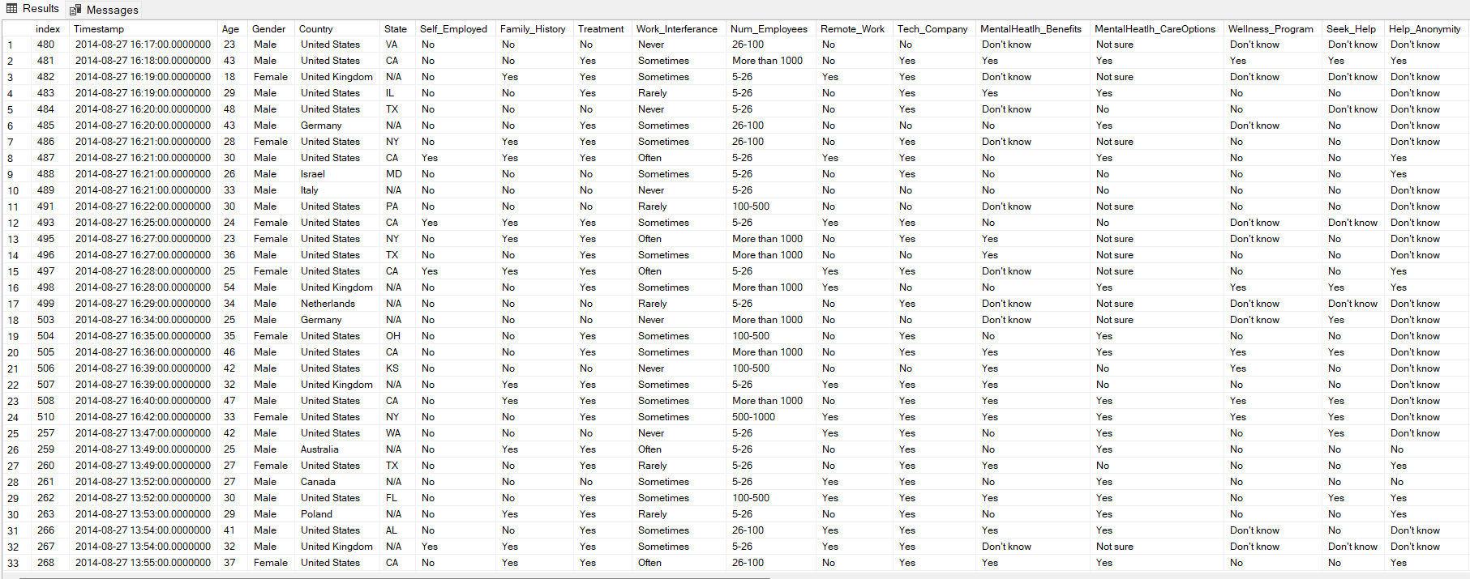Credit:

[Mental Health in Tech Survey (kaggle.com)](https://www.kaggle.com/datasets/osmi/mental-health-in-tech-survey/data)

[Mental Health in Tech Survey - dataset by quanticdata | data.world](https://data.world/quanticdata/mental-health-in-tech-survey)